|  |
| --- |
|  |
| A Prototype for Boutiqa |
| A Comprehensive Guide to Developing a High-Fidelity Prototype using Axure RP |
|  |
| **John Edward Oblepias** |
| **11/30/2023** |

This document presents the process and outcomes of designing a high-fidelity prototype for Boutiqa, an online marketplace aimed at facilitating seamless transactions between sellers and consumers. The prototype, developed using Axure RP, focuses on enhancing user experience by providing a rich internet application that is both seller and consumer-centric. The document details the functionalities available to both user types, including registration, profile management, product catalog maintenance for sellers, and product search and selection for consumers. It further outlines the scope of the project, which includes prototype design, development, and usability testing. This documentation serves as a comprehensive guide to understanding the design process and the strategic decisions made to ensure the application is user-friendly, efficient, and effective.

Table of Contents

[To update the table of contents, right click the message below and select Update Field (F9 on PC, ⌥⌘U on Mac).]

1. Pages 8

1.1. Page Tree 8

1.2. Landing Page 9

1.2.1. User Interface 9

1.2.2. Widget Table 9

1.2.3. Products 10

1.2.3.1. User Interface 10

1.3. Product Details (From Landing page)) 11

1.3.1. User Interface 11

1.3.2. Widget Table 11

1.3.3. Unnamed 12

1.3.3.1. State 1 12

1.3.3.2. User Interface 12

1.3.3.3. State 2 12

1.3.3.4. User Interface 12

1.3.3.5. State 3 13

1.3.3.6. User Interface 13

1.3.3.7. State 4 13

1.3.3.8. User Interface 13

1.3.3.9. State 5 14

1.3.3.10. User Interface 14

1.3.3.11. State 6 14

1.3.3.12. User Interface 14

1.3.3.13. State 7 15

1.3.3.14. User Interface 15

1.3.3.15. State 8 15

1.3.3.16. User Interface 15

1.4. Categorized Products 16

1.4.1. User Interface 16

1.4.2. Widget Table 16

1.4.3. Products 17

1.4.3.1. User Interface 17

1.5. Search Results (Landing Page) 18

1.5.1. User Interface 18

1.5.2. Widget Table 18

1.5.3. Products 19

1.5.3.1. User Interface 19

1.6. Product Details (From Search Results)) 20

1.6.1. User Interface 20

1.6.2. Widget Table 20

1.6.3. Unnamed 21

1.6.3.1. State 1 21

1.6.3.2. User Interface 21

1.6.3.3. State 2 21

1.6.3.4. User Interface 21

1.6.3.5. State 3 22

1.6.3.6. User Interface 22

1.6.3.7. State 4 22

1.6.3.8. User Interface 22

1.6.3.9. State 5 23

1.6.3.10. User Interface 23

1.6.3.11. State 6 23

1.6.3.12. User Interface 23

1.6.3.13. State 7 24

1.6.3.14. User Interface 24

1.6.3.15. State 8 24

1.6.3.16. User Interface 24

1.7. Sign Up (Buyer) 25

1.7.1. User Interface 25

1.7.2. Widget Table 25

1.8. (Buyer) Sign Up Confirmation Page 26

1.8.1. User Interface 26

1.9. (Buyer) Successful registration 27

1.9.1. User Interface 27

1.10. Sign Up (Seller) 28

1.10.1. User Interface 28

1.10.2. Widget Table 28

1.11. (Seller) Sign Up Confirmation Page 29

1.11.1. User Interface 29

1.12. (Seller) Successful registration 30

1.12.1. User Interface 30

1.13. Log In 31

1.13.1. User Interface 31

1.13.2. Widget Table 31

1.14. BuyerDashboard 32

1.14.1. User Interface 32

1.14.2. Widget Table 32

1.14.3. Products 33

1.14.3.1. User Interface 33

1.15. Product Details (From Homepage) 34

1.15.1. User Interface 34

1.15.2. Unnamed 35

1.15.2.1. State 1 35

1.15.2.2. User Interface 35

1.15.2.3. State 2 35

1.15.2.4. User Interface 35

1.15.2.5. State 3 36

1.15.2.6. User Interface 36

1.15.2.7. State 4 36

1.15.2.8. User Interface 36

1.15.2.9. State 5 37

1.15.2.10. User Interface 37

1.15.2.11. State 6 37

1.15.2.12. User Interface 37

1.15.2.13. State 7 38

1.15.2.14. User Interface 38

1.15.2.15. State 8 38

1.15.2.16. User Interface 38

1.16. Categorized Products 39

1.16.1. User Interface 39

1.16.2. Widget Table 39

1.16.3. Products 40

1.16.3.1. User Interface 40

1.17. Buyer Profile 41

1.17.1. User Interface 41

1.18. Search Results 42

1.18.1. User Interface 42

1.18.2. Widget Table 42

1.18.3. Products 43

1.18.3.1. User Interface 43

1.19. Product Details (From Search Results)) 44

1.19.1. User Interface 44

1.19.2. Unnamed 45

1.19.2.1. State 1 45

1.19.2.2. User Interface 45

1.19.2.3. State 2 45

1.19.2.4. User Interface 45

1.19.2.5. State 3 46

1.19.2.6. User Interface 46

1.19.2.7. State 4 46

1.19.2.8. User Interface 46

1.19.2.9. State 5 47

1.19.2.10. User Interface 47

1.19.2.11. State 6 47

1.19.2.12. User Interface 47

1.19.2.13. State 7 48

1.19.2.14. User Interface 48

1.19.2.15. State 8 48

1.19.2.16. User Interface 48

1.20. SellerDashboard 49

1.20.1. User Interface 49

1.20.2. Products 50

1.20.2.1. User Interface 50

1.21. Product Details (From Homepage) (1) 51

1.21.1. User Interface 51

1.21.2. Unnamed 52

1.21.2.1. State 1 52

1.21.2.2. User Interface 52

1.21.2.3. State 2 52

1.21.2.4. User Interface 52

1.21.2.5. State 3 53

1.21.2.6. User Interface 53

1.21.2.7. State 4 53

1.21.2.8. User Interface 53

1.21.2.9. State 5 54

1.21.2.10. User Interface 54

1.21.2.11. State 6 54

1.21.2.12. User Interface 54

1.21.2.13. State 7 55

1.21.2.14. User Interface 55

1.21.2.15. State 8 55

1.21.2.16. User Interface 55

1.22. Seller Profile 56

1.22.1. User Interface 56

2. Components 57

2.1. Component List 57

2.2. LandingPageNavBar 58

2.2.1. User Interface 58

2.2.2. Widget Table 58

2.3. BuyerNavBar 59

2.3.1. User Interface 59

2.3.2. Widget Table 59

2.4. SellerNavBar 60

2.4.1. User Interface 60

2.4.2. Widget Table 60

2.5. CategoriesNavBar 61

2.5.1. User Interface 61

2.6. Common Footer 62

2.6.1. User Interface 62

1. Pages
   1. Page Tree

Public  
 Landing Page  
 Product Details (From Landing page))  
 Categorized Products  
 Search Results (Landing Page)  
 Product Details (From Search Results))  
 Sign Up (Buyer)  
 (Buyer) Sign Up Confirmation Page  
 (Buyer) Successful registration  
 Sign Up (Seller)  
 (Seller) Sign Up Confirmation Page  
 (Seller) Successful registration  
 Log In  
Private  
 Buyer  
 BuyerDashboard  
 Product Details (From Homepage)  
 Categorized Products  
 Buyer Profile  
 Search Results  
 Product Details (From Search Results))  
 Seller  
 SellerDashboard  
 Product Details (From Homepage) (1)  
 Seller Profile

* 1. Landing Page

Landing page. Contains products and the links for regisration and log in page

* + 1. User Interface

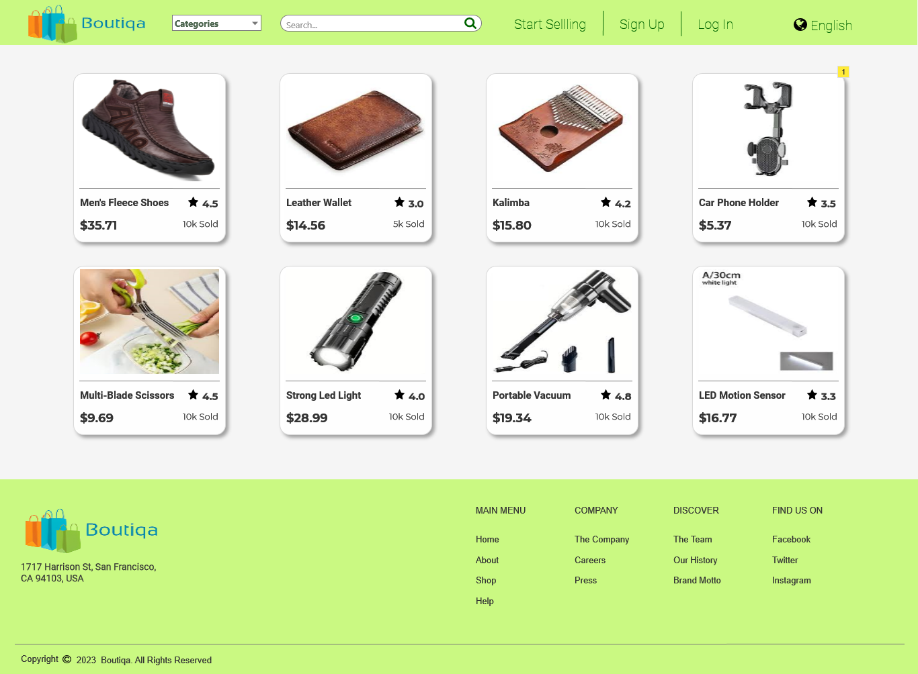

* + 1. Widget Table

|  |  |  |
| --- | --- | --- |
| Note number | Name | Note |
| 1 | Products | Product lists |

* + 1. Products
       1. User Interface

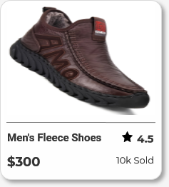

Product Details (From Landing page))

Page Loaded:  
 Set text on ProductName equal to value of DetailsProductName  
 Set text on ProductPrice equal to value of DetailsProductPrice  
 Set text on ProductRatings equal to value of DetailsProductRatings  
 Set text on ProductSoldPlaceholder equal to value of DetailsProductSold  
 Set text on ProductDetails equal to value of DetailsProductDescription  
 Set text on ProductNameBreadcrum equal to value of DetailsProductName  
 Set (Dynamic Panel) to to [[DetailsProductImage]]

* + 1. User Interface

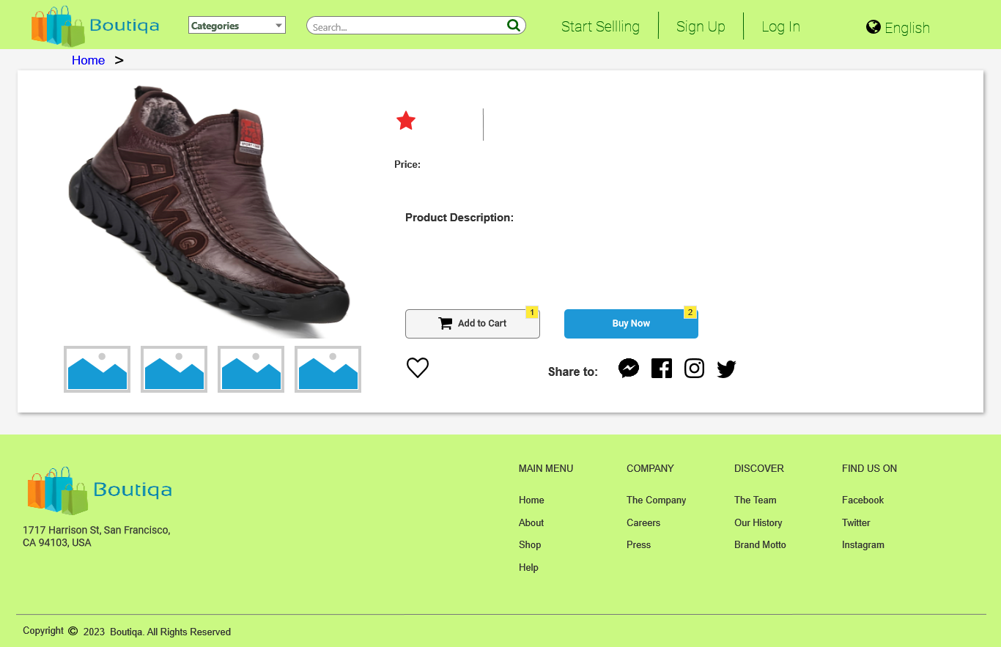

* + 1. Widget Table

|  |  |  |  |
| --- | --- | --- | --- |
| Note number | Name | Interactions | Note |
| 1 |  |  | This button links to buyer sign up page since you cannot buy a product if you are not using an account |
| 2 | Buy now button |  | This button links to buyer sign up page since you cannot buy a product if you are not using an account |

* + 1. Unnamed
       1. State 1
       2. User Interface

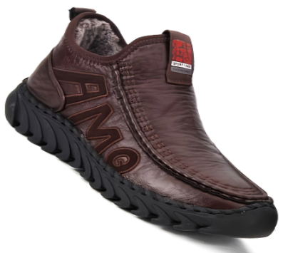

* + - 1. State 2
      2. User Interface

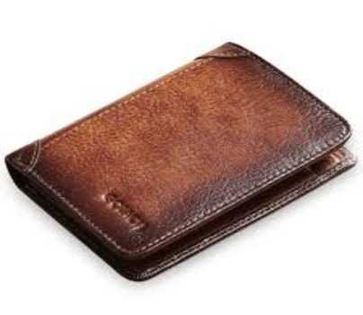

* + - 1. State 3
      2. User Interface

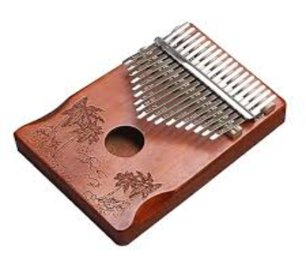

* + - 1. State 4
      2. User Interface

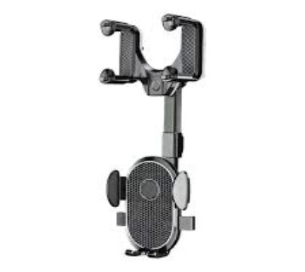

* + - 1. State 5
      2. User Interface



* + - 1. State 6
      2. User Interface

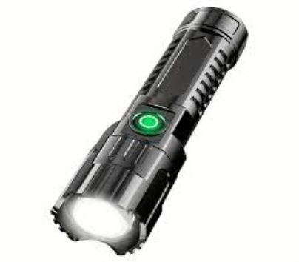

* + - 1. State 7
      2. User Interface

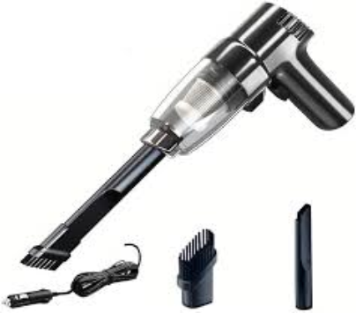

* + - 1. State 8
      2. User Interface

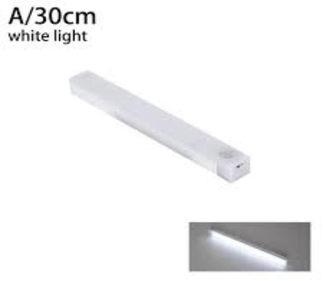

* 1. Categorized Products

This page filters the products based from the categories chosen. When choosing categories from the nav bar, the user will be directed to this page.

Page Loaded:  
 Add Filter ProductCategoryNum contains "[[CategoryNumber]]" to Products

* + 1. User Interface

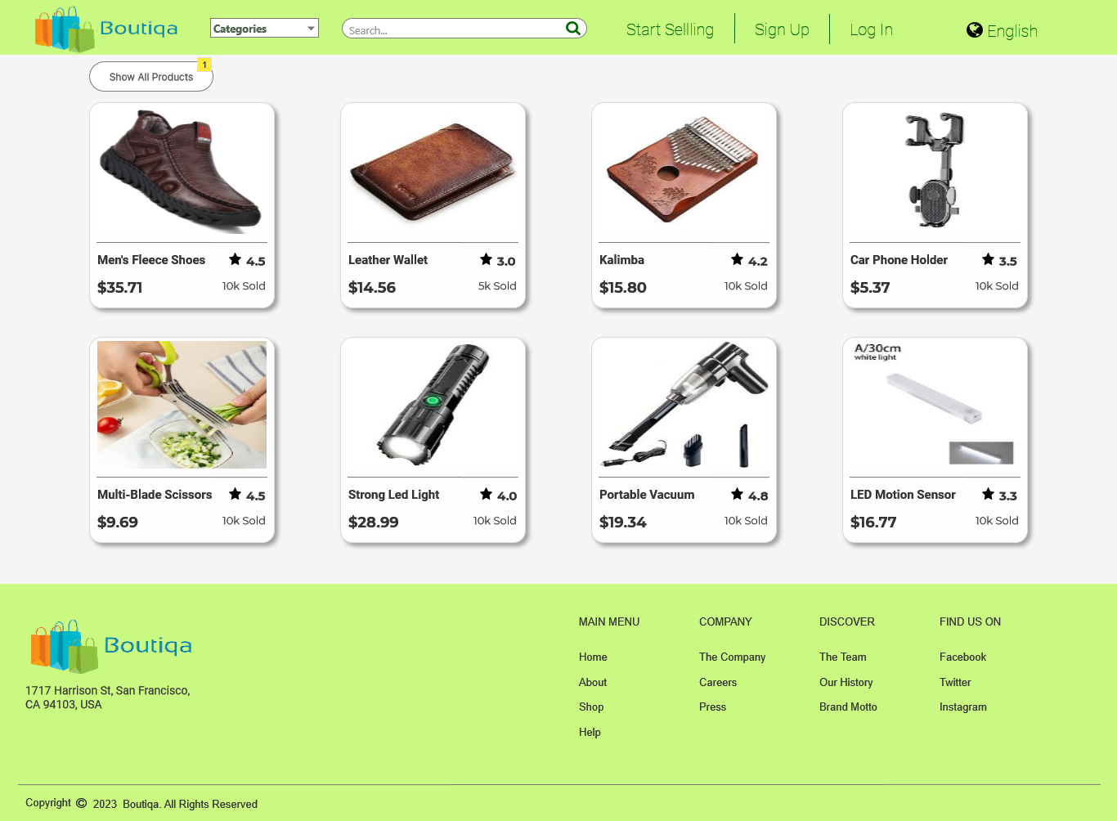

* + 1. Widget Table

|  |  |  |  |
| --- | --- | --- | --- |
| Note number | Name | Interactions | Note |
| 1 | Show all product button |  | Directs the user to the dashboard to show all the products |

* + 1. Products
       1. User Interface



* 1. Search Results (Landing Page)

This page filters the products based from what was being searched in the search bar. This is the page where the user will be directed when they use the search bar.

Page Loaded:  
 Set text on SearchKeywordPlaceholder equal to value of SearchKeyword  
 Set text on (LandingPageNavBar)/SearchBarInput equal to value of SearchKeyword  
 Add Filter ProductName contains "[[SearchKeyword]]" to Products

* + 1. User Interface

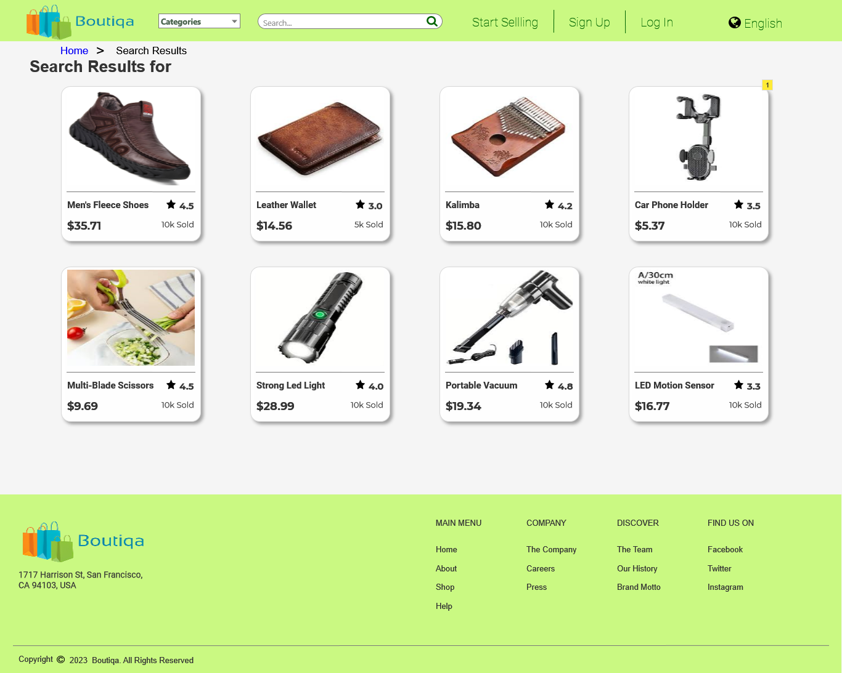

* + 1. Widget Table

|  |  |  |  |
| --- | --- | --- | --- |
| Note number | Name | Interactions | Note |
| 1 | Products |  | Filtered products based from the search search input |

* + 1. Products
       1. User Interface



* 1. Product Details (From Search Results))

This page is similar with product details page but only differs with the breadcrumbs

Page Loaded:  
 Set text on ProductName equal to value of DetailsProductName  
 Set text on ProductPrice equal to value of DetailsProductPrice  
 Set text on ProductRatings equal to value of DetailsProductRatings  
 Set text on ProductSoldPlaceholder equal to value of DetailsProductSold  
 Set text on ProductDetails equal to value of DetailsProductDescription  
 Set text on ProductNameBreadcrum equal to value of DetailsProductName  
 Set (Dynamic Panel) to to [[DetailsProductImage]]

* + 1. User Interface

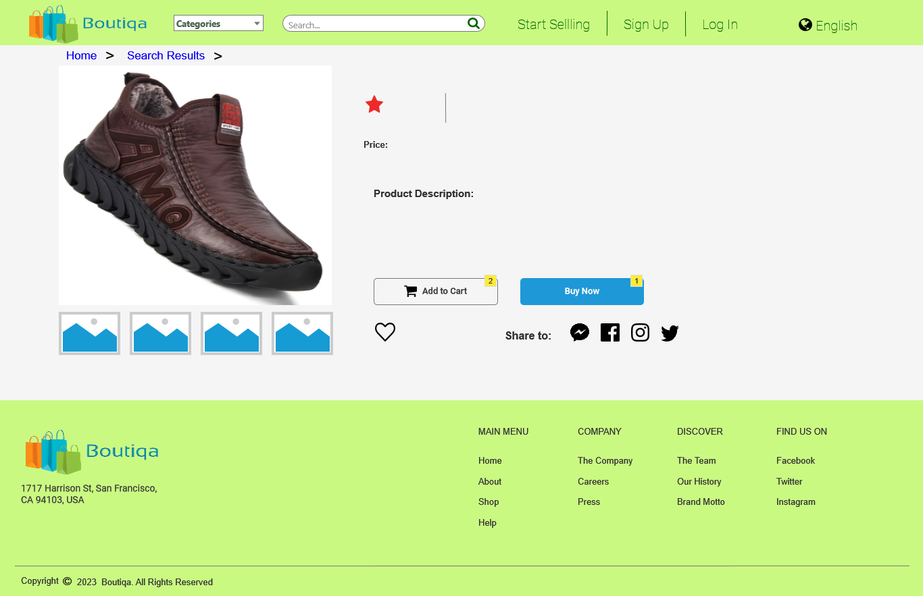

* + 1. Widget Table

|  |  |  |  |
| --- | --- | --- | --- |
| Note number | Name | Interactions | Note |
| 1 | Buy now button |  | This button links to buyer sign up page since you cannot buy a product if you are not using an account |
| 2 | Add to cart button |  | This button links to buyer sign up page since you cannot buy a product if you are not using an account |

* + 1. Unnamed
       1. State 1
       2. User Interface



* + - 1. State 2
      2. User Interface



* + - 1. State 3
      2. User Interface



* + - 1. State 4
      2. User Interface



* + - 1. State 5
      2. User Interface



* + - 1. State 6
      2. User Interface



* + - 1. State 7
      2. User Interface



* + - 1. State 8
      2. User Interface



* 1. Sign Up (Buyer)
     1. User Interface

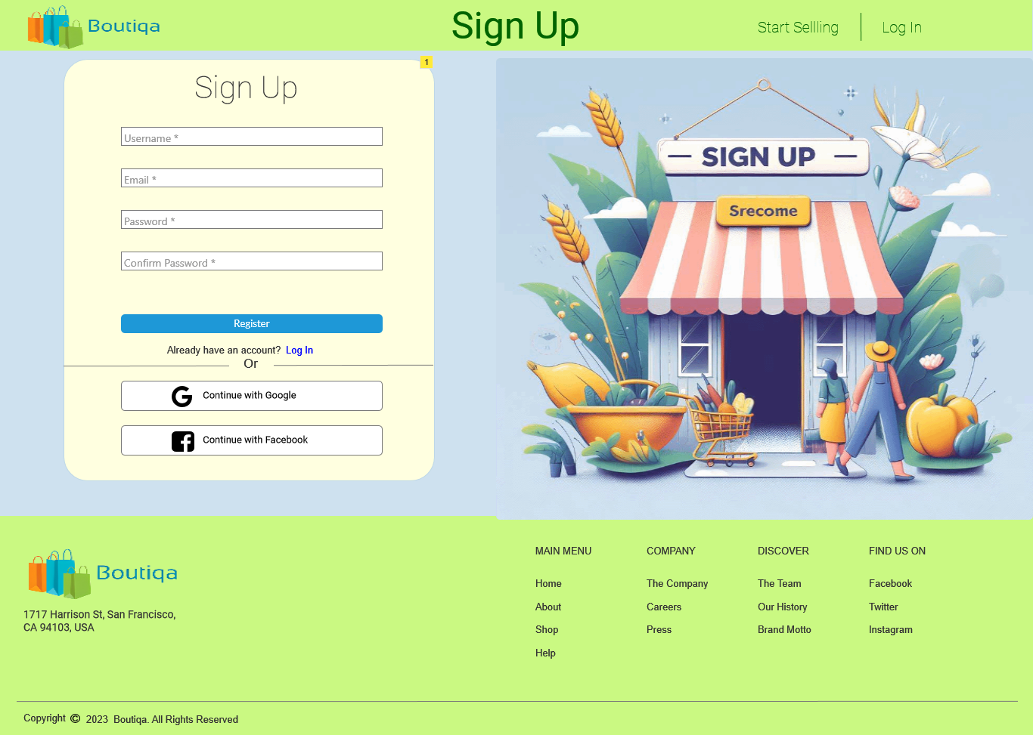

* + 1. Widget Table

|  |  |  |  |
| --- | --- | --- | --- |
| Note number | Name | Interactions | Note |
| 1 | Registration form |  | Registration form which contains fields for user input like Username, email, password, and password confirmation. |

* 1. (Buyer) Sign Up Confirmation Page

Page Loaded:  
 Set text on ConfirmUsername equal to value of Username  
 Set text on ConfirmEmail equal to value of Email

* + 1. User Interface

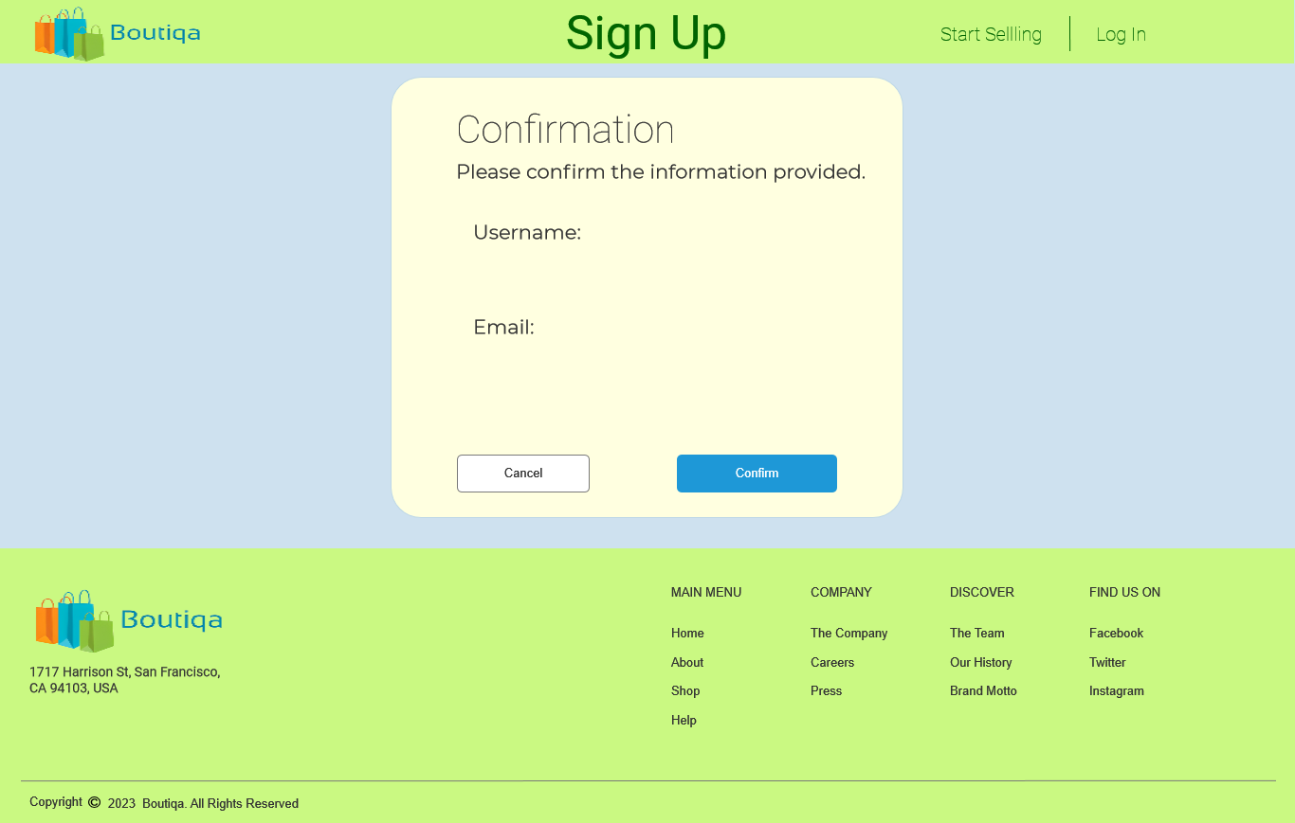

* 1. (Buyer) Successful registration
     1. User Interface

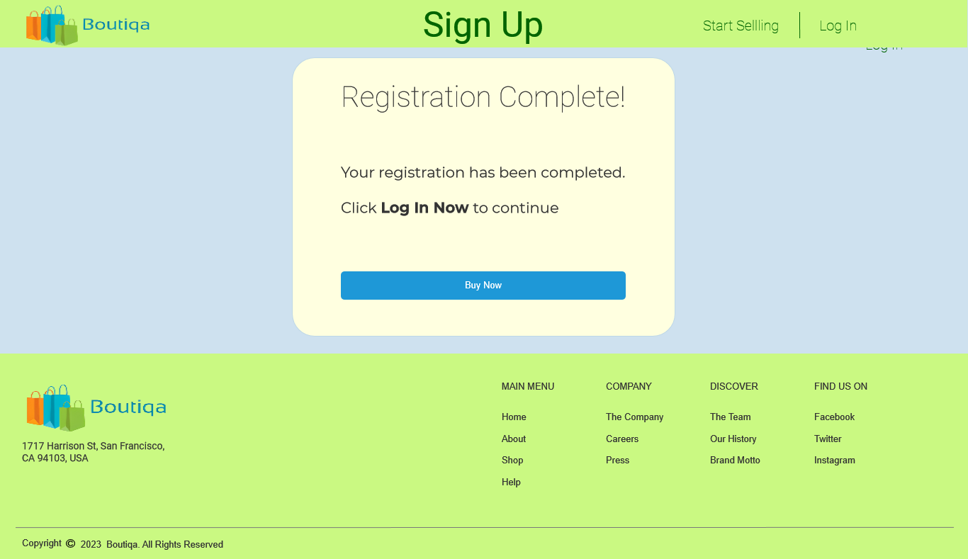

* 1. Sign Up (Seller)
     1. User Interface

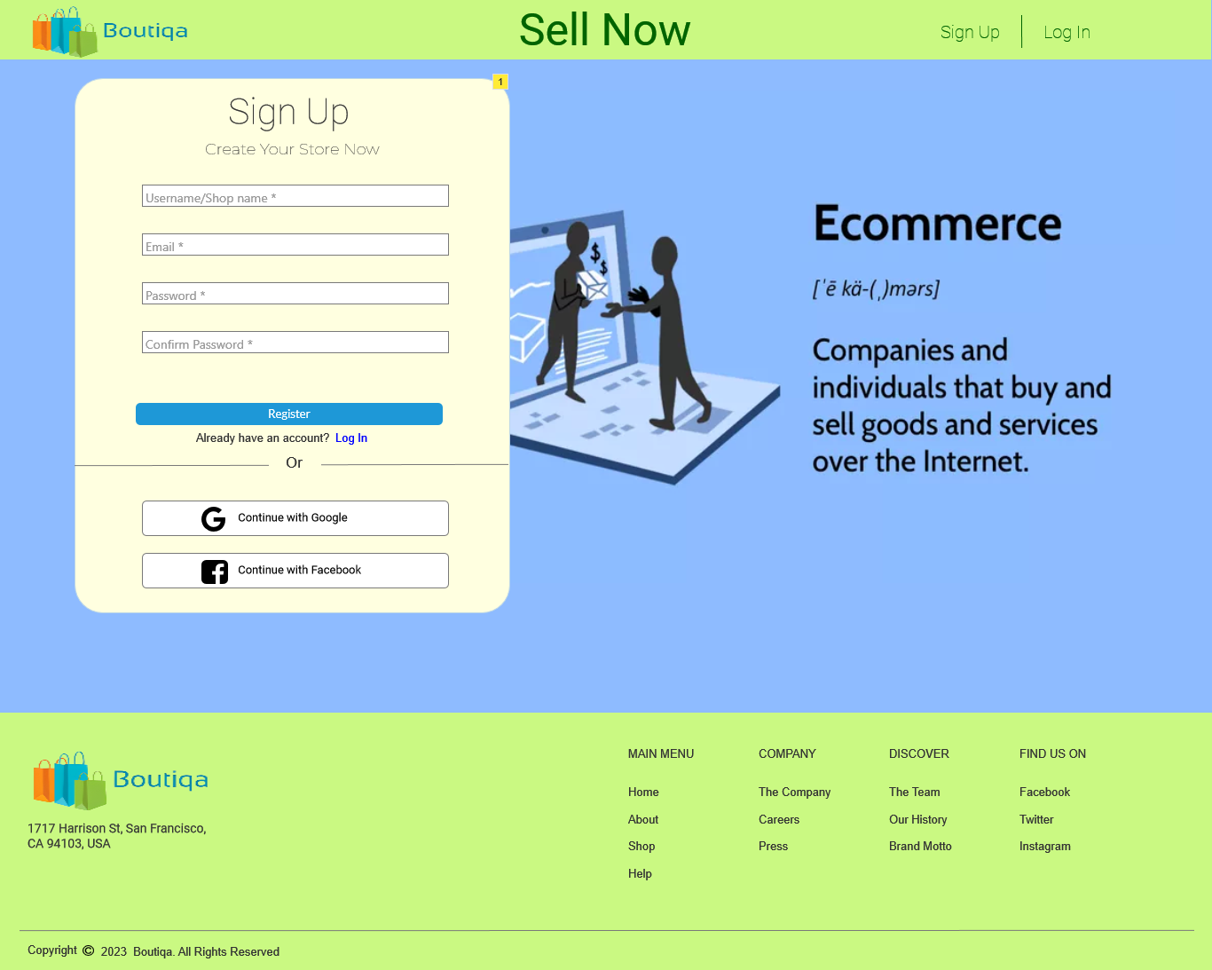

* + 1. Widget Table

|  |  |  |  |
| --- | --- | --- | --- |
| Note number | Name | Interactions | Note |
| 1 | Registration form for Seller |  | Registration form which contains fields for user input like Username, email, password, and password confirmation. |

* 1. (Seller) Sign Up Confirmation Page

Page Loaded:  
 Set text on ConfirmUsername equal to value of SellerUserName  
 Set text on ConfirmEmail equal to value of SellerEmail

* + 1. User Interface

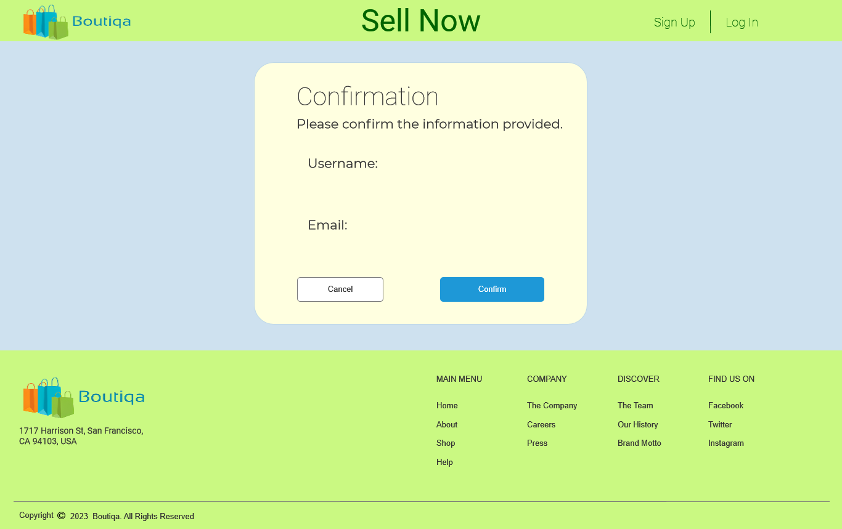

* 1. (Seller) Successful registration
     1. User Interface

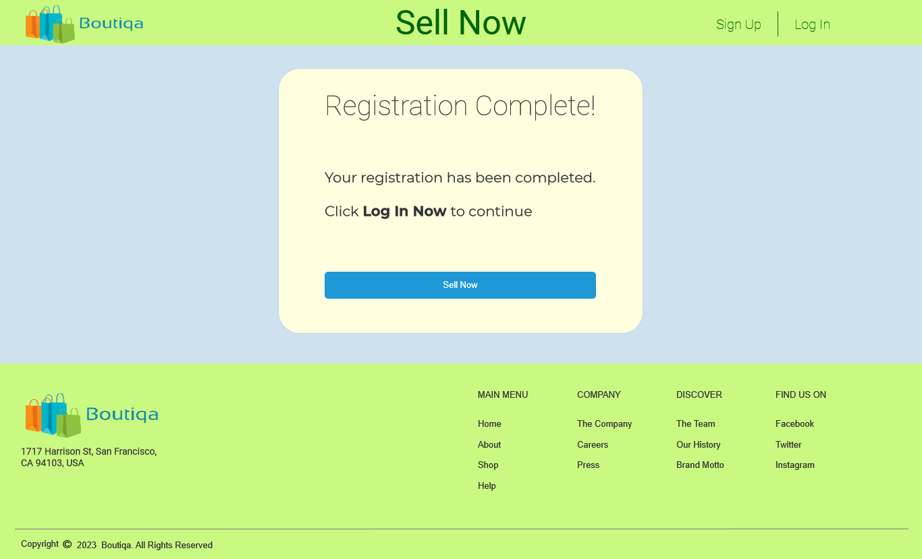

* 1. Log In
     1. User Interface

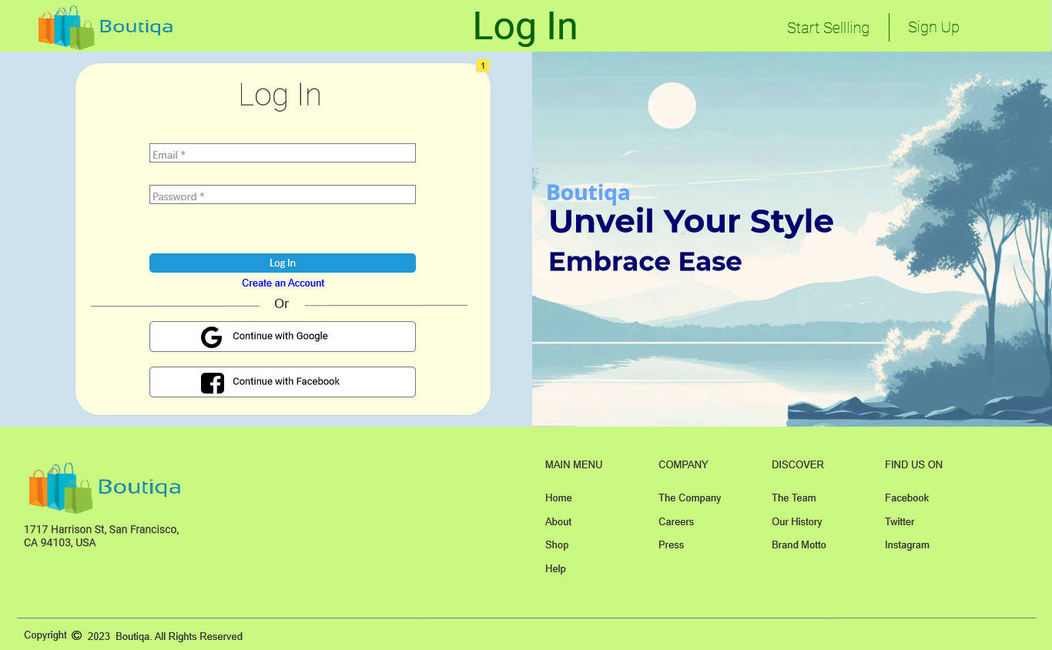

* + 1. Widget Table

|  |  |  |  |
| --- | --- | --- | --- |
| Note number | Name | Interactions | Note |
| 1 | Log in form |  | Log in form that contains field for user input like Email and password |

* 1. BuyerDashboard

Almost similar with the the landing page, but this page already has userprofile on the navbar, and has a dropdown that has links for the user profile and for logging out

Page Loaded:  
 Set text on (BuyerNavBar)/UsernamePlacholder equal to value of Username  
 Set text on (BuyerNavBar)/UsernamePlacholder equal to value of Username  
 Set text on (BuyerNavBar)/EmailPlaceholder equal to value of Email

* + 1. User Interface

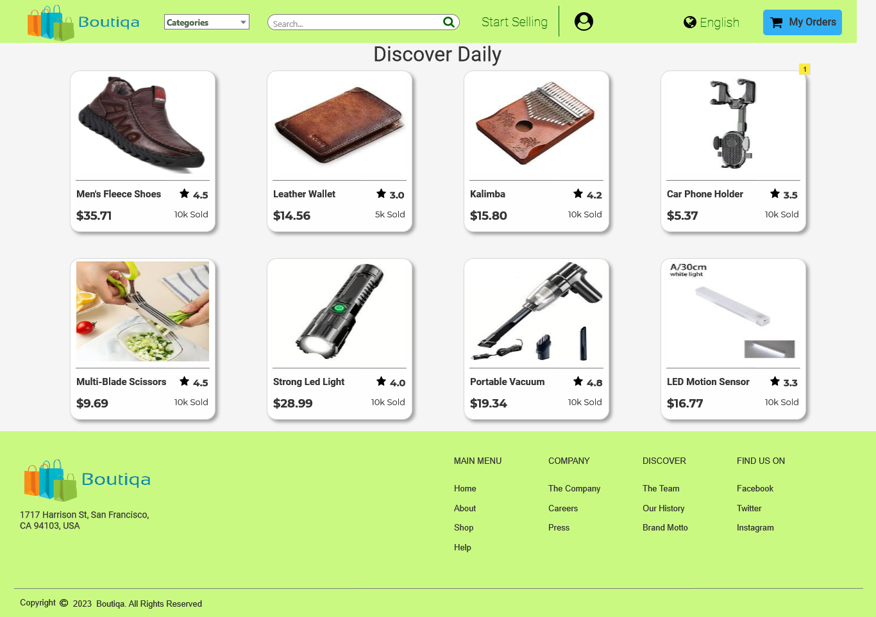

* + 1. Widget Table

|  |  |  |
| --- | --- | --- |
| Note number | Name | Note |
| 1 | Products | Product list |

* + 1. Products
       1. User Interface



Product Details (From Homepage)

page for only viewing the product details

Page Loaded:  
 Set text on (BuyerNavBar)/UsernamePlacholder equal to value of Username  
 Set text on (BuyerNavBar)/UsernamePlacholder equal to value of Username  
 Set text on (BuyerNavBar)/EmailPlaceholder equal to value of Email  
 Set text on ProductName equal to value of DetailsProductName  
 Set text on ProductPrice equal to value of DetailsProductPrice  
 Set text on ProductRatings equal to value of DetailsProductRatings  
 Set text on ProductSoldPlaceholder equal to value of DetailsProductSold  
 Set text on ProductDetails equal to value of DetailsProductDescription  
 Set text on ProductNameBreadcrum equal to value of DetailsProductName  
 Set (Dynamic Panel) to to [[DetailsProductImage]]

* + 1. User Interface

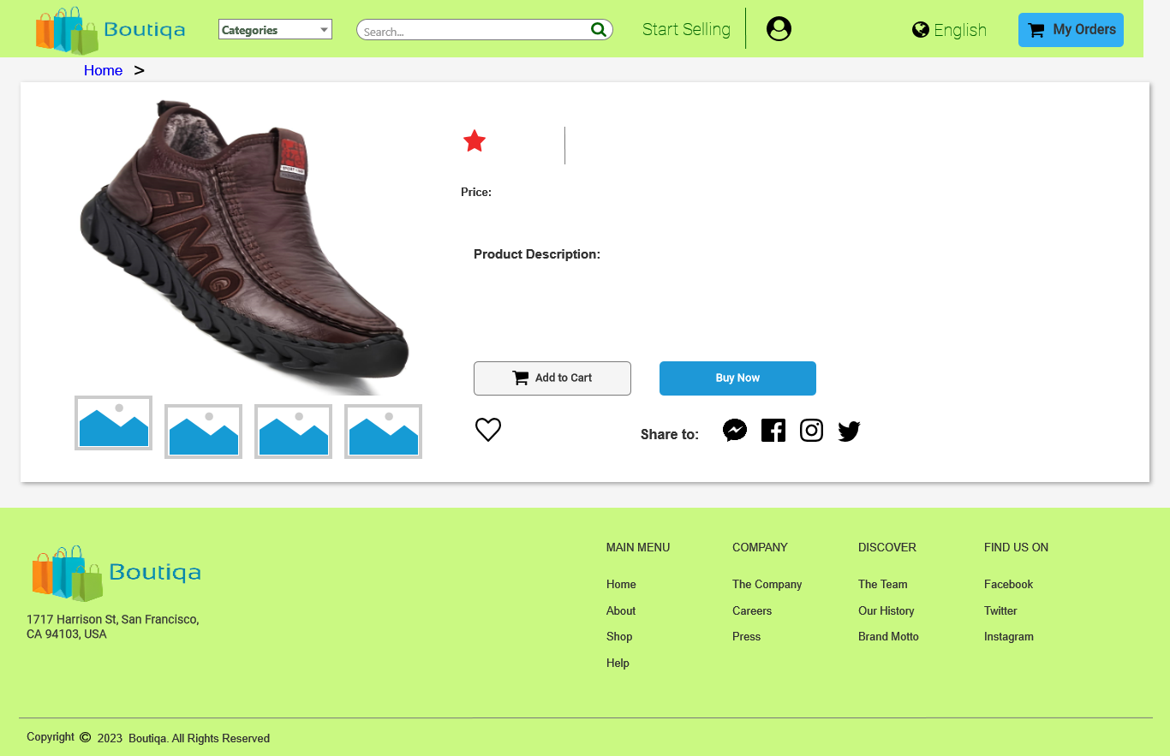

* + 1. Unnamed
       1. State 1
       2. User Interface



* + - 1. State 2
      2. User Interface



* + - 1. State 3
      2. User Interface



* + - 1. State 4
      2. User Interface



* + - 1. State 5
      2. User Interface



* + - 1. State 6
      2. User Interface



* + - 1. State 7
      2. User Interface



* + - 1. State 8
      2. User Interface



* 1. Categorized Products

This page filters the products based from the categories chosen. When choosing categories from the nav bar, the user will be directed to this page.

Page Loaded:  
 Add Filter ProductCategoryNum contains "[[CategoryNumber]]" to Products  
 Set text on (BuyerNavBar)/UsernamePlacholder equal to value of Username  
 Set text on (BuyerNavBar)/UsernamePlacholder equal to value of Username  
 Set text on (BuyerNavBar)/EmailPlaceholder equal to value of Email

* + 1. User Interface

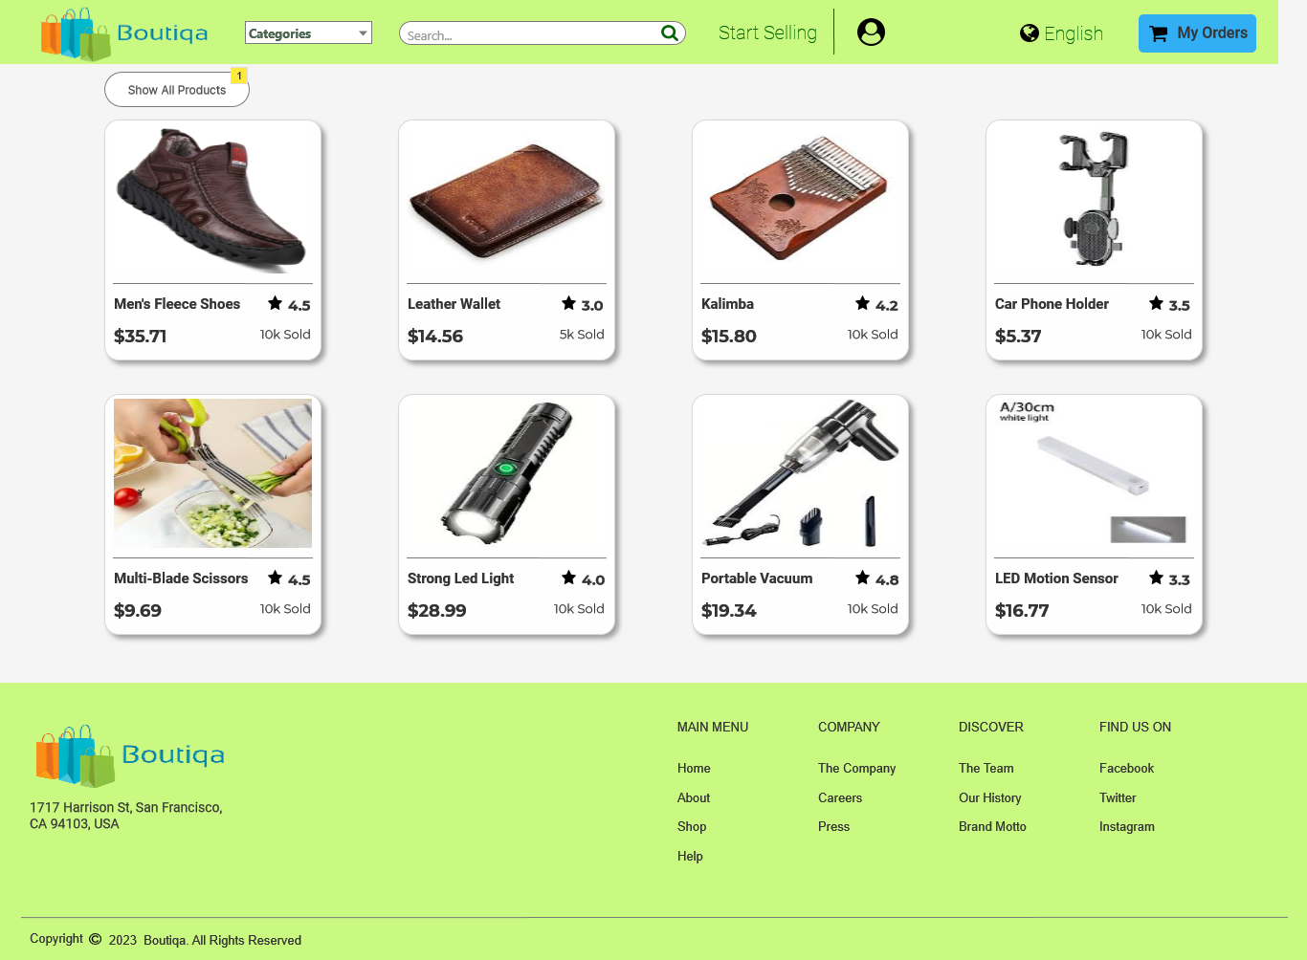

* + 1. Widget Table

|  |  |  |  |
| --- | --- | --- | --- |
| Note number | Name | Interactions | Note |
| 1 | Show all product button |  | Directs the user to the dashboard to show all the products |

* + 1. Products
       1. User Interface



* 1. Buyer Profile

This page shows the information of the user. The information shown mostly are from the signing up of the user. Users can also add and edit their information in this page by pressing the edit button.

Page Loaded:  
 Set text on (BuyerNavBar)/UsernamePlacholder equal to value of Username  
 Set text on (BuyerNavBar)/UsernamePlacholder equal to value of Username  
 Set text on (BuyerNavBar)/EmailPlaceholder equal to value of Email  
 Set text on ProfileUsernamePlacholder equal to value of Username  
 Set text on EmailPlaceholder equal to value of Email  
 Set text on Full Name Placeholder equal to value of FullName  
 Set text on Username Placeholder equal to value of Username  
 Set text on Email Placeholder equal to value of Email  
 Set text on Password Placeholder equal to value of Password  
 Set text on Mobile Number Placeholder equal to value of MobileNumber  
 Disable Full Name Placeholder  
 Disable Username Placeholder  
 Disable Email Placeholder  
 Disable Password Placeholder  
 Disable Mobile Number Placeholder

* + 1. User Interface

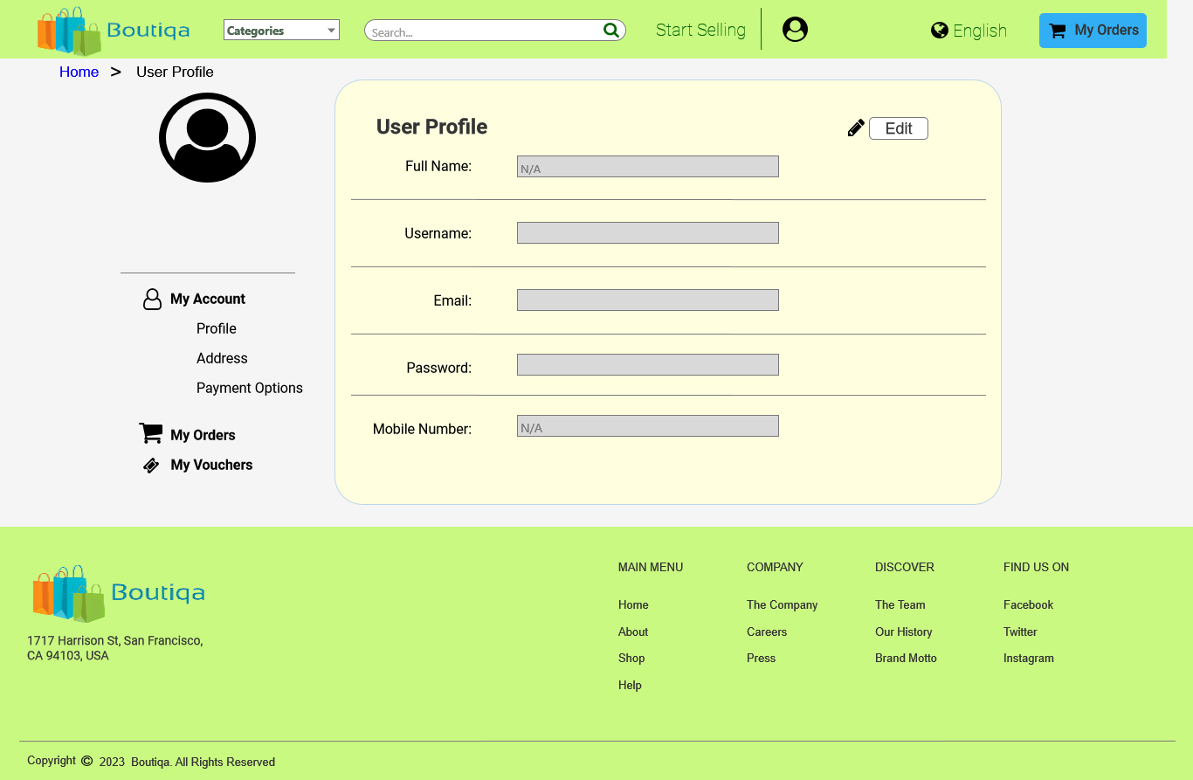

* 1. Search Results

This page filters the products based from what was being searched in the search bar. This is the page where the user will be directed when they use the search bar.

Page Loaded:  
 Set text on (BuyerNavBar)/UsernamePlacholder equal to value of Username  
 Set text on (BuyerNavBar)/UsernamePlacholder equal to value of Username  
 Set text on (BuyerNavBar)/EmailPlaceholder equal to value of Email  
 Set text on SearchKeywordPlaceholder equal to value of SearchKeyword  
 Set text on (BuyerNavBar)/SearchBarInput equal to value of SearchKeyword  
 Add Filter ProductName contains text on (BuyerNavBar)/SearchBarInput to Products

* + 1. User Interface

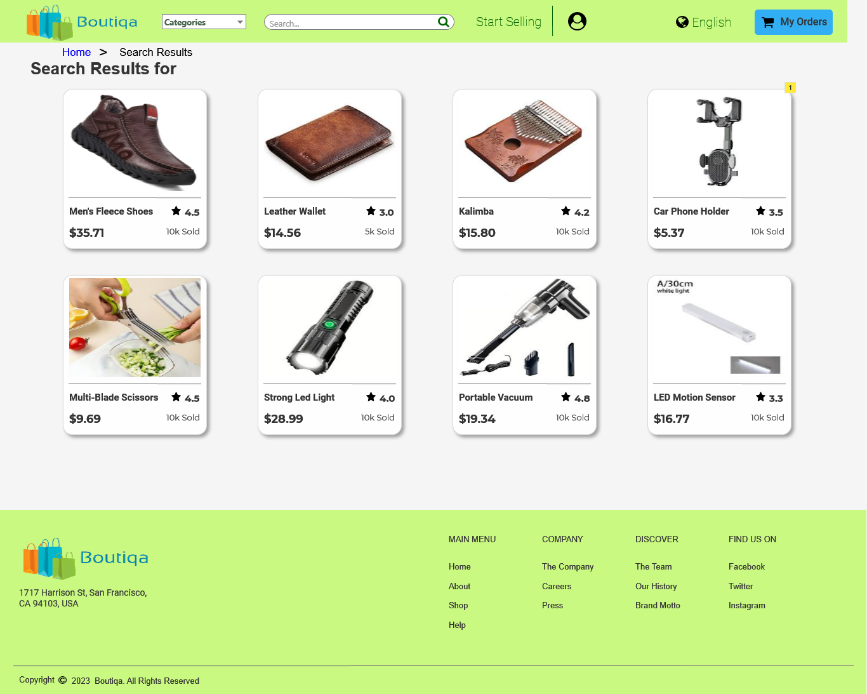

* + 1. Widget Table

|  |  |  |  |
| --- | --- | --- | --- |
| Note number | Name | Interactions | Note |
| 1 | Products |  | Filtered products based from the search input |

* + 1. Products
       1. User Interface



* 1. Product Details (From Search Results))

This page is similar with product details page but only differs with the breadcrumbs. Page only used for viewing the product details.

Page Loaded:  
 Set text on (BuyerNavBar)/UsernamePlacholder equal to value of Username  
 Set text on (BuyerNavBar)/UsernamePlacholder equal to value of Username  
 Set text on (BuyerNavBar)/EmailPlaceholder equal to value of Email  
 Set text on ProductName equal to value of DetailsProductName  
 Set text on ProductPrice equal to value of DetailsProductPrice  
 Set text on ProductRatings equal to value of DetailsProductRatings  
 Set text on ProductSoldPlaceholder equal to value of DetailsProductSold  
 Set text on ProductDetails equal to value of DetailsProductDescription  
 Set text on ProductNameBreadcrum equal to value of DetailsProductName  
 Set (Dynamic Panel) to to [[DetailsProductImage]]

* + 1. User Interface

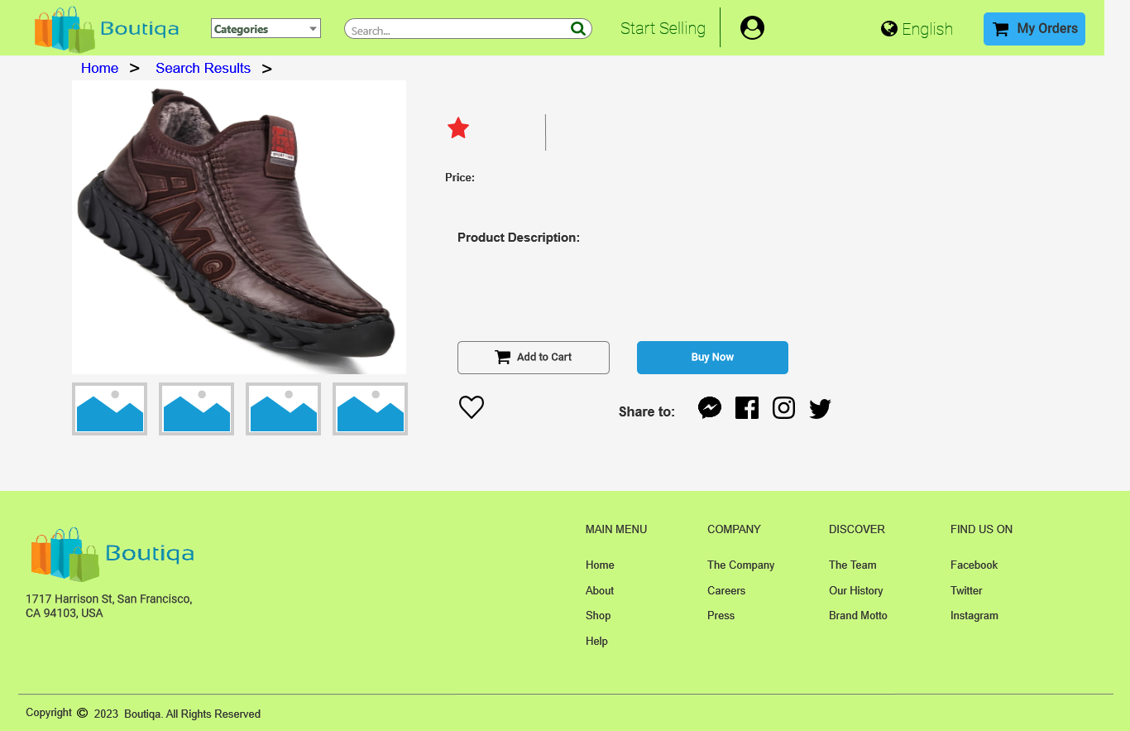

* + 1. Unnamed
       1. State 1
       2. User Interface



* + - 1. State 2
      2. User Interface



* + - 1. State 3
      2. User Interface



* + - 1. State 4
      2. User Interface



* + - 1. State 5
      2. User Interface



* + - 1. State 6
      2. User Interface



* + - 1. State 7
      2. User Interface



* + - 1. State 8
      2. User Interface



* 1. SellerDashboard

This page is the seller's dashboard where they can add or remove products form their product list

* + 1. User Interface

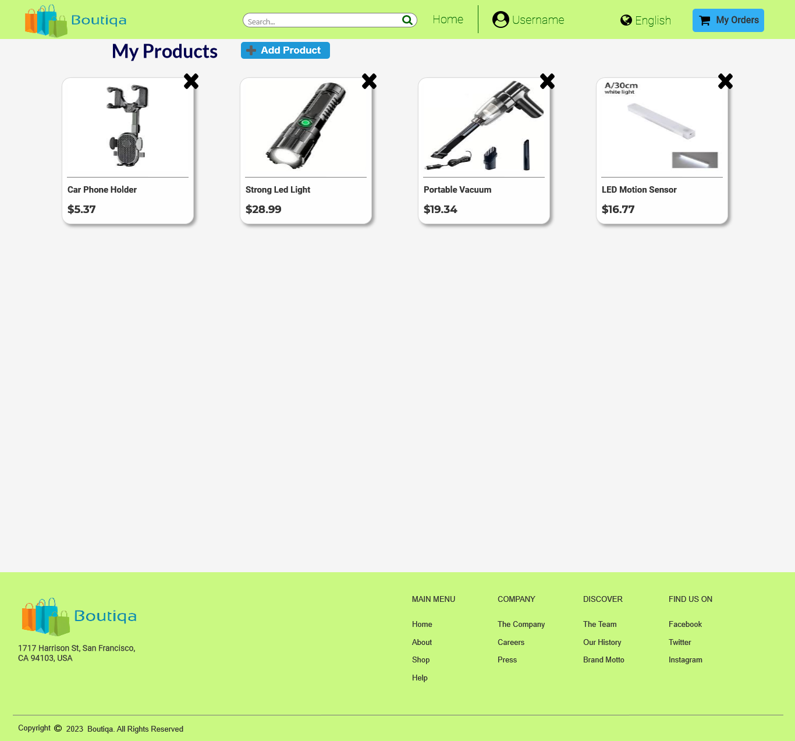

* + 1. Products
       1. User Interface

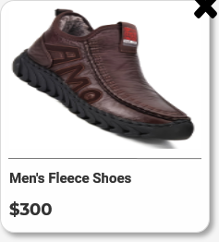

* 1. Product Details (From Homepage) (1)

Page only used for viewing the product details.

Page Loaded:  
 Set text on (SellerNavBar)/UsernamePlacholder equal to value of SellerUserName  
 Set text on (SellerNavBar)/UsernamePlacholder equal to value of SellerUserName  
 Set text on (SellerNavBar)/EmailPlaceholder equal to value of SellerEmail  
 Set text on ProductName equal to value of DetailsProductName  
 Set text on ProductPrice equal to value of DetailsProductPrice  
 Set text on ProductDetails equal to value of DetailsProductDescription  
 Set text on ProductNameBreadcrum equal to value of DetailsProductName  
 Set (Dynamic Panel) to to [[DetailsProductImage]]

* + 1. User Interface

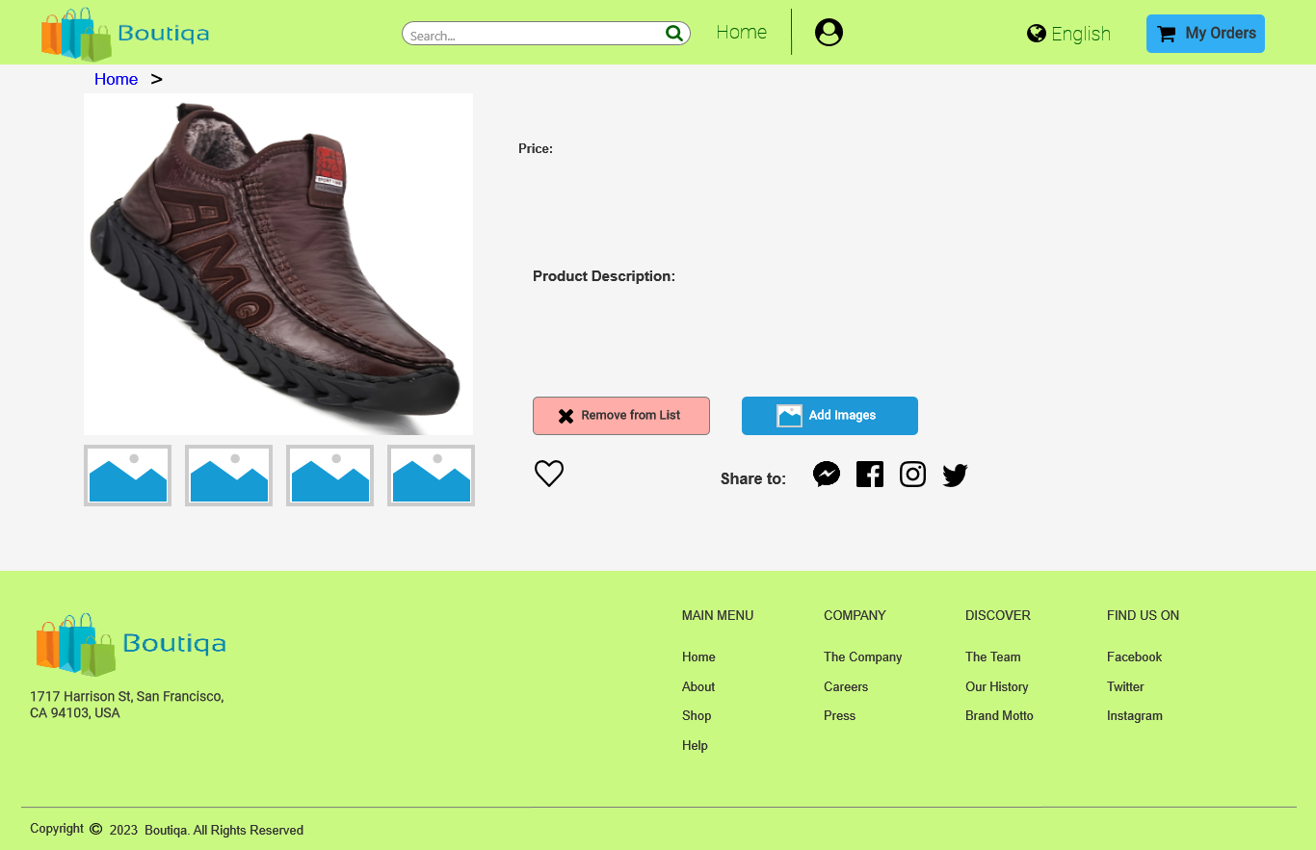

* + 1. Unnamed
       1. State 1
       2. User Interface



* + - 1. State 2
      2. User Interface



* + - 1. State 3
      2. User Interface



* + - 1. State 4
      2. User Interface



* + - 1. State 5
      2. User Interface



* + - 1. State 6
      2. User Interface



* + - 1. State 7
      2. User Interface



* + - 1. State 8
      2. User Interface



* 1. Seller Profile

This page shows the information of the user. The information shown mostly are from the signing up of the user. Users can also add and edit their information in this page by pressing the edit button.

Page Loaded:  
 Set text on (SellerNavBar)/UsernamePlacholder equal to value of SellerUserName  
 Set text on (SellerNavBar)/UsernamePlacholder equal to value of SellerUserName  
 Set text on (SellerNavBar)/EmailPlaceholder equal to value of SellerEmail  
 Set text on ProfileUsernamePlacholder equal to value of SellerUserName  
 Set text on EmailPlaceholder equal to value of SellerEmail  
 Set text on Shop Name Placeholder equal to value of SellerShopName  
 Set text on Username Placeholder equal to value of SellerUserName  
 Set text on Email Placeholder equal to value of SellerEmail  
 Set text on Password Placeholder equal to value of SellerPassword  
 Set text on Mobile Number Placeholder equal to value of SellerMobileNumber  
 Disable Shop Name Placeholder  
 Disable Username Placeholder  
 Disable Email Placeholder  
 Disable Password Placeholder  
 Disable Mobile Number Placeholder

* + 1. User Interface

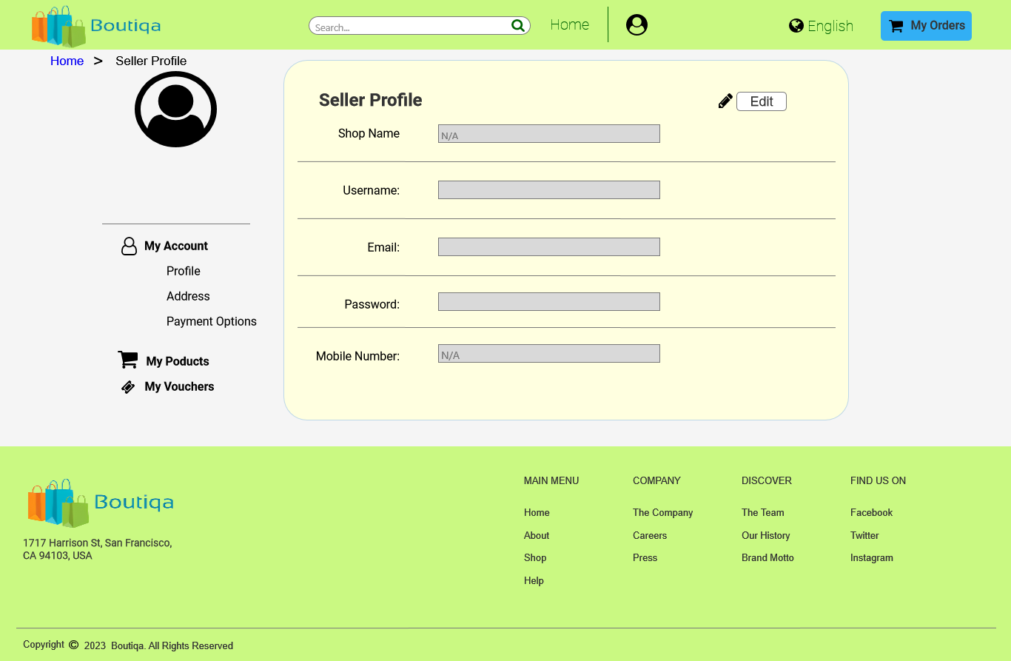

1. Components
   1. Component List

LandingPageNavBar  
BuyerNavBar  
SellerNavBar  
CategoriesNavBar  
Common Footer

* 1. LandingPageNavBar
     1. User Interface



* + 1. Widget Table

|  |  |  |  |
| --- | --- | --- | --- |
| Note number | Name | Interactions | Note |
| 1 |  |  | Categories drop down |
| 2 | SearchBarInput |  | Search bar where you can input products. Directs users to the search results page. |
| 3 |  |  | Seller sign up page link |
| 4 |  |  | Buyer sign up page link |
| 5 |  |  | Login page link for either buyers and sellers |
| 6 | LanguageDropdownButton |  | Change language dropdown |
| 7 | Logo |  | When clicked, directs user to the landing page |

* 1. BuyerNavBar

Page Loaded:  
 Set text on UsernamePlacholder equal to value of Username  
 Set text on UsernamePlacholder equal to value of Username  
 Set text on EmailPlaceholder equal to value of Email

* + 1. User Interface



* + 1. Widget Table

|  |  |  |  |
| --- | --- | --- | --- |
| Note number | Name | Interactions | Note |
| 1 | CategoriesDroplist |  | Categories drop down |
| 2 | SearchBarInput |  | Search bar where you can input products. Directs users to the search results page. |
| 3 | Start Selling link |  | Directs user to sign up page for sellers. |
| 4 | UsernameDropdown |  | Dropdown showing username and email, link to the user profile and log out button. |
| 5 | LanguageDropdownButton |  | Change language dropdown |
| 6 | Logo |  | When clicked, directs user to the buyer dashboard page |

* 1. SellerNavBar

Page Loaded:  
 Set text on UsernamePlacholder equal to value of SellerUserName  
 Set text on UsernamePlacholder equal to value of SellerUserName  
 Set text on EmailPlaceholder equal to value of SellerEmail

* + 1. User Interface



* + 1. Widget Table

|  |  |  |  |
| --- | --- | --- | --- |
| Note number | Name | Interactions | Note |
| 1 | Logo |  | When clicked, directs user to seller dashboard page |
| 2 | SearchBarInput |  | Search bar where you can input products. |
| 3 | Home link |  | Directs user to the seller dashboard page |
| 4 | UsernameDropdown |  | Dropdown showing username and email, link to the user profile and log out button. |
| 5 | LanguageDropdownButton |  | Change language dropdown |

* 1. CategoriesNavBar

Categories drop down

Page Loaded:  
 Enable/Disable Widget

* + 1. User Interface



* 1. Common Footer
     1. User Interface

